Department of Civil and Environmental Engineering

The Hong Kong University of Science and Technology

**CIVL 1100**

**Discovering Civil and Environmental Engineering**



***Lab Session for Environmental Engineering***

Lab Report on Data Recording Sheet and Question Answering

(Spring 2024)

|  |  |
| --- | --- |
| Full Name (in BLOCK letters) | Student ID |
|  |  |
|  |  |
|  |  |
|  |  |
| **Due date of Submission: 2 April (For session LA1-1, 1-2, 2-1, and 2-2); 16 April (For session LA1-3, 1-4, 2-3, and 2-4)**  **Submit a PDF copy of your lab report to Canvas before 11:59 pm on the assigned due date (late submissions will not be accepted).** | |

**Part 1: Soil**

**Experiment 1 (i): Measurement of Soil pH**

***Results*** (1 marks)

|  |  |  |  |
| --- | --- | --- | --- |
| Trial 1 | Trial 2 | Trial 3 | Average |
|  |  |  |  |

Note:

1. For teaching purpose, readings are recorded in 30 seconds for each trial.

***Questions***

1. Does the average pH of the soil sample provide the ideal pH conditions for plant growth (Please refer to Appendix A)? (1 marks)

Note: There is no Hong Kong pH scale currently for plant growth purpose. Therefore, Australia (New South Wales) pH scale is used.

__________________________________________________________________

1. Provide possible factors that can affect the soil pH. (2 marks)

__________________________________________________________________________________________________________________________________________________________________________________________________________________________________________________________________________________________________________________________________________

1. Arsenic is a toxic heavy metal. In Hong Kong, high arsenic level was detected in the soil in the North East New Territories New Development Areas. Explain why the measurement of soil pH is important for remediating the soil contaminated by arsenic? (1 marks)

________________________________________________________________________________________________________________________________________________________________________________________________________________________________________________________________________

**Experiment 1 (ii): Measurement of Soil-gas Radon Level**

***Results*** (1 marks)

|  |  |  |  |
| --- | --- | --- | --- |
| Trial 1 (Bq/m3) | Trial 2 (Bq/m3) | Trial 3 (Bq/m3) | Average (Bq/m3) |
|  |  |  |  |

Note:

* + - 1. Bq/m3: becquerels per cubic meter.

***Questions***

1. Is radon in soil considered as acute*[1]* or chronic*[2]* exposure to human beings? (1 marks)

__________________________________________________________________

1. Apart from measuring the soil-gas radon level, we also measure the radon level in indoor air and drinking water. Why does radon exist in indoor air and drinking water? (2 marks)

__________________________________________________________________________________________________________________________________________________________________________________________________________________________________________________________________________________________________________________________________________

**Part 2: Indoor Air Quality**

**Experiment 2 (i): Measurement of Relative Humidity, Carbon Dioxide (CO2), and Carbon Monoxide (CO)**

***Results***

1. Measurement of Relative Humidity (1 marks)

|  |  |  |  |
| --- | --- | --- | --- |
| Trial 1 (%) | Trial 2 (%) | Trial 3 (%) | Average (%) |
|  |  |  |  |

1. Measurement of Carbon Dioxide (CO2) (1 marks)

|  |  |  |  |
| --- | --- | --- | --- |
| Trial 1 (ppmv) | Trial 2 (ppmv) | Trial 3 (ppmv) | Average (ppmv) |
|  |  |  |  |

1. Measurement of Carbon Monoxide (CO) (1 marks)

|  |  |  |  |
| --- | --- | --- | --- |
| Trial 1 (ppmv) | Trial 2 (ppmv) | Trial 3 (ppmv) | Average (ppmv) |
|  |  |  |  |

Note:

1. ppmv: parts per million by volume.
2. For teaching purpose, readings are recorded in 30 seconds instead of 8-hour average according to the Hong Kong Indoor Air Quality Objectives for Offices and Public Places.

***Questions***

1. Based on the Hong Kong Indoor Air Quality Objectives for Offices and Public Places in Appendix B, please tick the box(es) if the measured value(s) meet(s) the 8-hour average objectives. (1 marks)

|  |  |  |
| --- | --- | --- |
| Parameter | 8-hour average | |
| Excellent Class | Good Class |
| Relative Humidity |  |  |
| Carbon Dioxide (CO2) |  |  |
| Carbon Monoxide (CO) |  |  |

1. What are the immediate and long-term health effects of exposure to poor indoor air quality? (2 marks)

__________________________________________________________________________________________________________________________________________________________________________________________________________________________________________________________________________________________________________________________________________

1. “ppmv” and “ppm” are the units commonly used to express the concentration of a pollutant in air and water, respectively. (i) What is the difference between these two units? (ii) In water or wastewater sample, it is often assumed that 1 ppm equals 1 mg/L because the density of water or wastewater sample is close to 1 kg/L if the pollutant concentration is not high. However, when dealing with concentration of a gas (e.g. CO, NOx, SOx) in air, this assumption is invalid. Please explain the reason. (2 marks)

__________________________________________________________________________________________________________________________________________________________________________________________________________________________________________________________________________________________________________________________________________________________________________________________________________________________________________________________________________________________________________________________________________________________________________________________________________________

**Experiment 2 (iia): Measurement of Respirable Suspended Particulates (RSP)**

***Results*** (1 marks)

|  |  |  |  |
| --- | --- | --- | --- |
| Trial 1 (mg/m3) | Trial 2 (mg/m3) | Trial 3 (mg/m3) | Average (mg/m3) |
|  |  |  |  |

Note:

1. For teaching purpose, readings are recorded in 60 seconds instead of 8-hour average according to the Hong Kong Indoor Air Quality Objectives for Offices and Public Places.

***Questions***

1. Based on the Hong Kong Indoor Air Quality Objectives for Offices and Public Places in Appendix B, please tick the box(es) if the measured value meets the 8-hour average objectives. (1 marks)

Note: 1 mg/m3 = 1000 µg/m3

|  |  |  |
| --- | --- | --- |
| Parameter | 8-hour average | |
| Excellent Class | Good Class |
| Respirable Suspended Particulates (RSP) |  |  |

1. Beijing has started the measurement of PM­2.5­ as one of the indicators for air quality since 2012. Do you agree that PM2.5 poses greater health risks to human than that of PM10 and why? If yes, do we still need to measure PM10? (2 marks)

__________________________________________________________________________________________________________________________________________________________________________________________________________________________________________________________________________________________________________________________________________

__________________________________________________________________

__________________________________________________________________

**Experiment 2 (iib): Measurement of Total Volatile Organic Compounds (TVOC)**

***Results*** (1 marks)

|  |  |  |  |
| --- | --- | --- | --- |
| Trial 1 (ppbv) | Trial 2 (ppbv) | Trial 3 (ppbv) | Average (ppbv) |
|  |  |  |  |

Note:

1. ppbv: parts per billion by volume.
2. For teaching purpose, reading is recorded in a period of every 30 seconds instead of 8-hour average according to the Hong Kong Indoor Air Quality Objectives for Offices and Public Places.

***Questions***

1. Based on the Hong Kong Indoor Air Quality Objectives for Offices and Public Places in Appendix B, please tick the box(es) if the measured value(s) meet(s) the 8-hour average objectives. (1 marks)

|  |  |  |
| --- | --- | --- |
| Parameter | 8-hour average | |
| Excellent Class | Good Class |
| Total Volatile Organic Compounds (TVOC) |  |  |

1. To cater for the additional students from the reformed “334” academic structure, new academic buildings were built in local universities in 2012. However, it was reported that the TVOC concentration was very high in the newly established buildings. Give two possible causes. (2 marks)

____________________________________________________________________________________________________________________________________________________________________________________________________________________________________________________________________________________________________________________________________________________________________________________________________________

**Part 3: Water**

**Experiment 3 (i): Measurement of Dissolved Oxygen**

***Results*** (1 marks)

|  |  |  |  |
| --- | --- | --- | --- |
| Trial 1 (mg/L) | Trial 2 (mg/L) | Trial 3 (mg/L) | Average (mg/L) |
|  |  |  |  |

Note:

1. For teaching purpose, readings are recorded in 30 seconds for each trial.

***Questions***

1. Assuming that the wastewater sample will be discharged into Group A inland water, does the concentration of average dissolved oxygen in the wastewater sample meet the Hong Kong’s Effluent Discharge Standard? (Please refer to Appendix C and assume the flow rate to be 300 m3/day) (1 marks)

__________________________________________________________________

1. In late 2015, a large quantity of dead fish was found floating in Shing Mun River in Sha Tin. One of the possible causes for the fish death might be due to the low level of dissolved oxygen in the river. List two factors that can lead to a low level of dissolved oxygen. (2 marks)

__________________________________________________________________________________________________________________________________________________________________________________________________________________________________________________________________________________________________________________________________________

__________________________________________________________________

__________________________________________________________________

__________________________________________________________________

1. Besides the fish death, Shing Mun River was also notorious for the unpleasant odor in the 1980s. One expert suggested that this could also be associated with the low level of dissolved oxygen in the river. Do you agree and why? (2 marks)

__________________________________________________________________________________________________________________________________________________________________________________________________________________________________________________________________________________________________________________________________________

____________________________________________________________________________________________________________________________________

__________________________________________________________________

__________________________________________________________________

__________________________________________________________________

**Experiment 3 (ii): Measurement of Turbidity**

***Results*** (1 marks)

|  |  |  |  |
| --- | --- | --- | --- |
| Trial 1 (NTU) | Trial 2 (NTU) | Trial 3 (NTU) | Average (NTU) |
|  |  |  |  |

Note:

1. NTU: Nephelometric Turbidity Unit.

***Questions***

1. Assuming that the tap water sample will be used as drinking water, does the average concentration of turbidity in tap water sample meet the Hong Kong’s Drinking Water Quality? (Please refer to Appendix D) (1 marks)

__________________________________________________________________

1. On September 28, 2015, drinking water supplies in Taipei and New Taipei City were partially suspended as a result of a very high turbidity level in raw water caused by Typhoon Dujuan. The turbidity of drinking water was still unacceptable even after water treatment.   
     
   (i) Provide two possible causes for the turbidity level to increase. (2 marks)

(ii) Why turbidity in drinking water should be controlled? (1 marks)

__________________________________________________________________________________________________________________________________________________________________________________________________________________________________________________________________________________________________________________________________________

____________________________________________________________________________________________________________________________________

____________________________________________________________________________________________________________________________________

__________________________________________________________________

**Appendix A: pH Scale for Plant Growth**

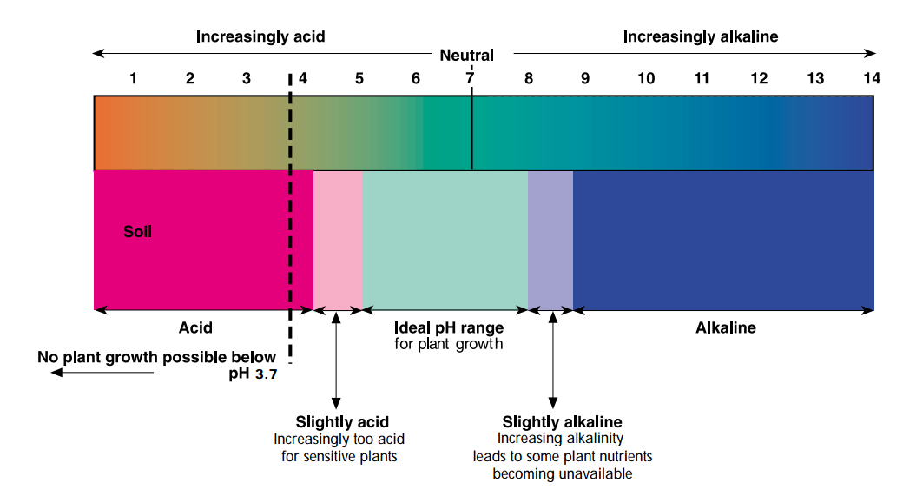

Source: New South Wales Acid Soil Action Program, Department of Agriculture, Australia, 2000.

**Appendix B: Hong Kong Indoor Air Quality Objectives for Offices and Public Places**

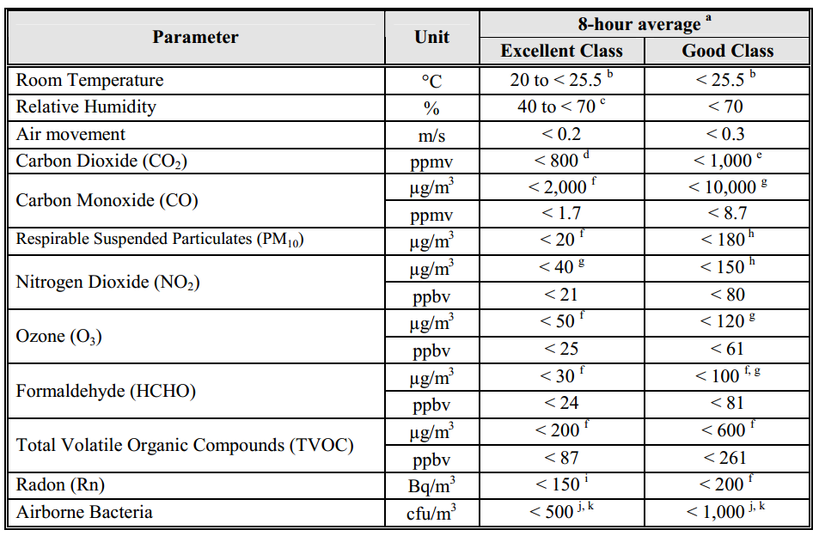

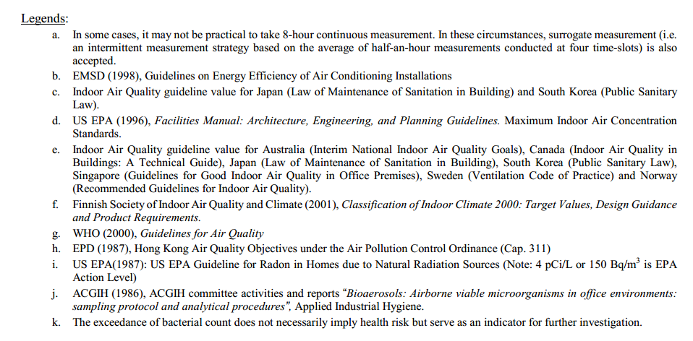

Source: Indoor Air Quality Management Group, the Government of the Hong Kong Special Administration Region, 2003.

**Appendix C: Hong Kong’s Effluent Discharge Standard**

Standards for effluents discharged into Group A* inland waters

(All units in mg/L unless otherwise stated; all figures are upper limits unless otherwise indicated)

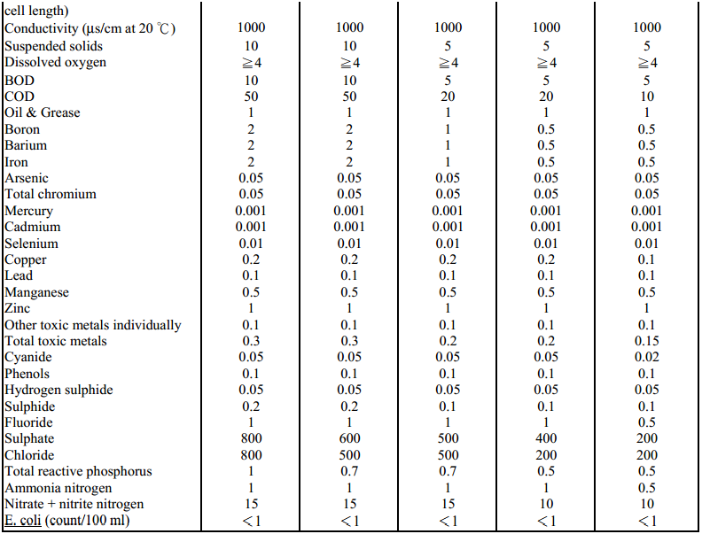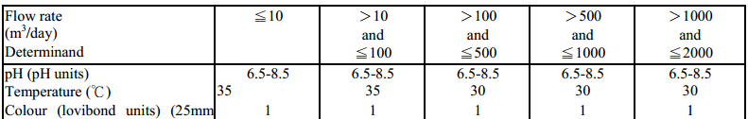

(Enacted 1990. 32 of 2000 s. 48)

*Group A: abstraction for potable water supply

Source: Chapter 358 AK, Technical Memorandum Standards for Effluents Discharged into Drainage and Sewerage Systems, Inland and Coastal Waters, 1997.

**Appendix D: Hong Kong’s Drinking Water Quality - World Health Organization's (WHO) Guidelines for Drinking-water Quality (2008)**

“Turbidity in drinking-water is caused by particulate matter that may be present from source water as a consequence of inadequate ﬁltration or from resuspension of sediment in the distribution system. It may also be due to the presence of inorganic particulate matter in some groundwaters or sloughing of bioﬁlm within the distribution system. The appearance of water with a turbidity of less than **5 NTU** is usually acceptable to consumers, although this may vary with local circumstances.”

Source: Guidelines for Drinking-Water Quality 3rd Edition Incorporating the First and Second Addenda, Volume 1, World Health Organization (WHO), 2008.

1. **Acute exposure** is exposure that occurs in a short time period. It can be an exposure that occurs once in your lifetime.
2. **Chronic exposure** is exposure that occurs over a long period of time. It can be continuous exposure, or it can be exposure that occurs off and on routinely over a long period of time in your life.